**Tutorial 1 Lab report**

**Hiteshwari Zala**

**AU2020033**

In a series of trials, the up-down staircase approach is intended to evaluate the threshold at a fixed performance level. The researcher establishes the baseline stimulus intensity and baseline stair step size before to each assessment. Based on the spectator's performance and a set of pre - defined rules, the technique modifies the stimulus level and step size. The staircase approach often needs a specific number of attempts to produce enough rollbacks to give a fairly accurate measure of the threshold. When using the staircase approach, S is acutely conscious of the order in which the stimuli are presented.

Alternative methods to find the stimulus threshold:

The method of limits:

It is an experimental method that measures the sensory threshold by gradually raising or reducing the amplitude of the stimulus provided in discrete stages until the participant notices the stimulus; at this point, the threshold level has been achieved. Using the method of limitations, one would start with a signal that is undetected and then progressively raise the strength until the patient could hear it.

The method of constant stimuli:

The method of constant stimuli involves giving the observer with a collection of stimuli, some of which are above the threshold and some of which are below the threshold, in a random order, in order to find the threshold. This is distinct from the boundaries technique, which presents stimuli in a random sequence. You always offer every stimulus while using the continuous stimuli strategy. This method makes it impossible for the observer to foresee or anticipate what the subsequent stimulus will be.

The absolute threshold method

The smallest stimulus level that may be recognised is known as an absolute threshold, which is often regarded as occurring at least half the time. The phrase is frequently used in neuroscience and experimental research and can be used to refer to any stimulus that can be picked up by the five senses of sight, hearing, touch, and smell.

Method

The raised respect that faces the border can be found using a variety of techniques. Once the chain has reached its final tier, the simplest approach is to calculate the average benefits of a particular number of tweaks. This involves selecting at random when the last level has been attained. To circumvent this issue, figure out which half of the comments are favourable on the upgrade and give a half's worth. Where and how to begin, as in most psychophysical procedures, a few initial series are critical to determining the range in which the boundary falls. The strategy is frequently successful as long as the primary modification is performed so that few first steps are required while approaching the edge.

Considering the step sizes, It is best to choose upgrading forces from a range that results in about comparable tactile stretching. Coefficient upgrades perform effectively for the bulk of applications of the approach. It's crucial to determine the means' lengths such that the interactions can only occur twice, three times, or four times before being inverted. The time to stop. In general, the outcomes of the staircase method show the advantages of the modifications. As long as the conditions don't change, these advantages fluctuate about this tier until they reach an optimal level or point. It goes without saying that the reported value of the edge will be more trustworthy the longer the series.

Results

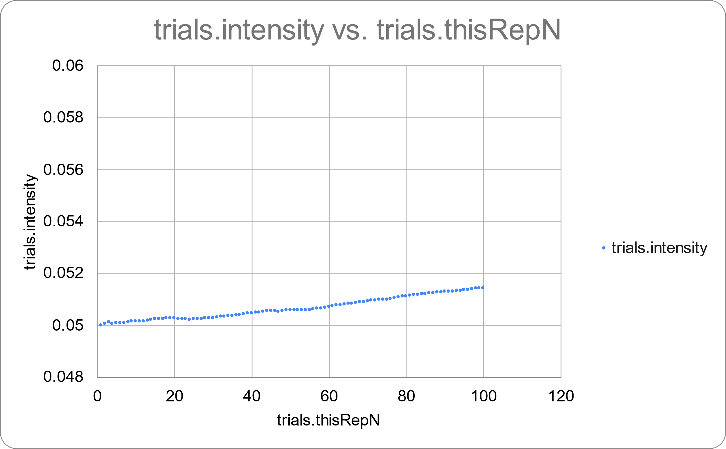

The relationship between the total number of trials and the degree of contrast is seen in the graph above. Here, we can observe that the contrast will decrease if the response is accurate and rise if the response is erroneous. The gradual increase in intensity, as seen above, suggests that a large number of the participant's replies were incorrect.

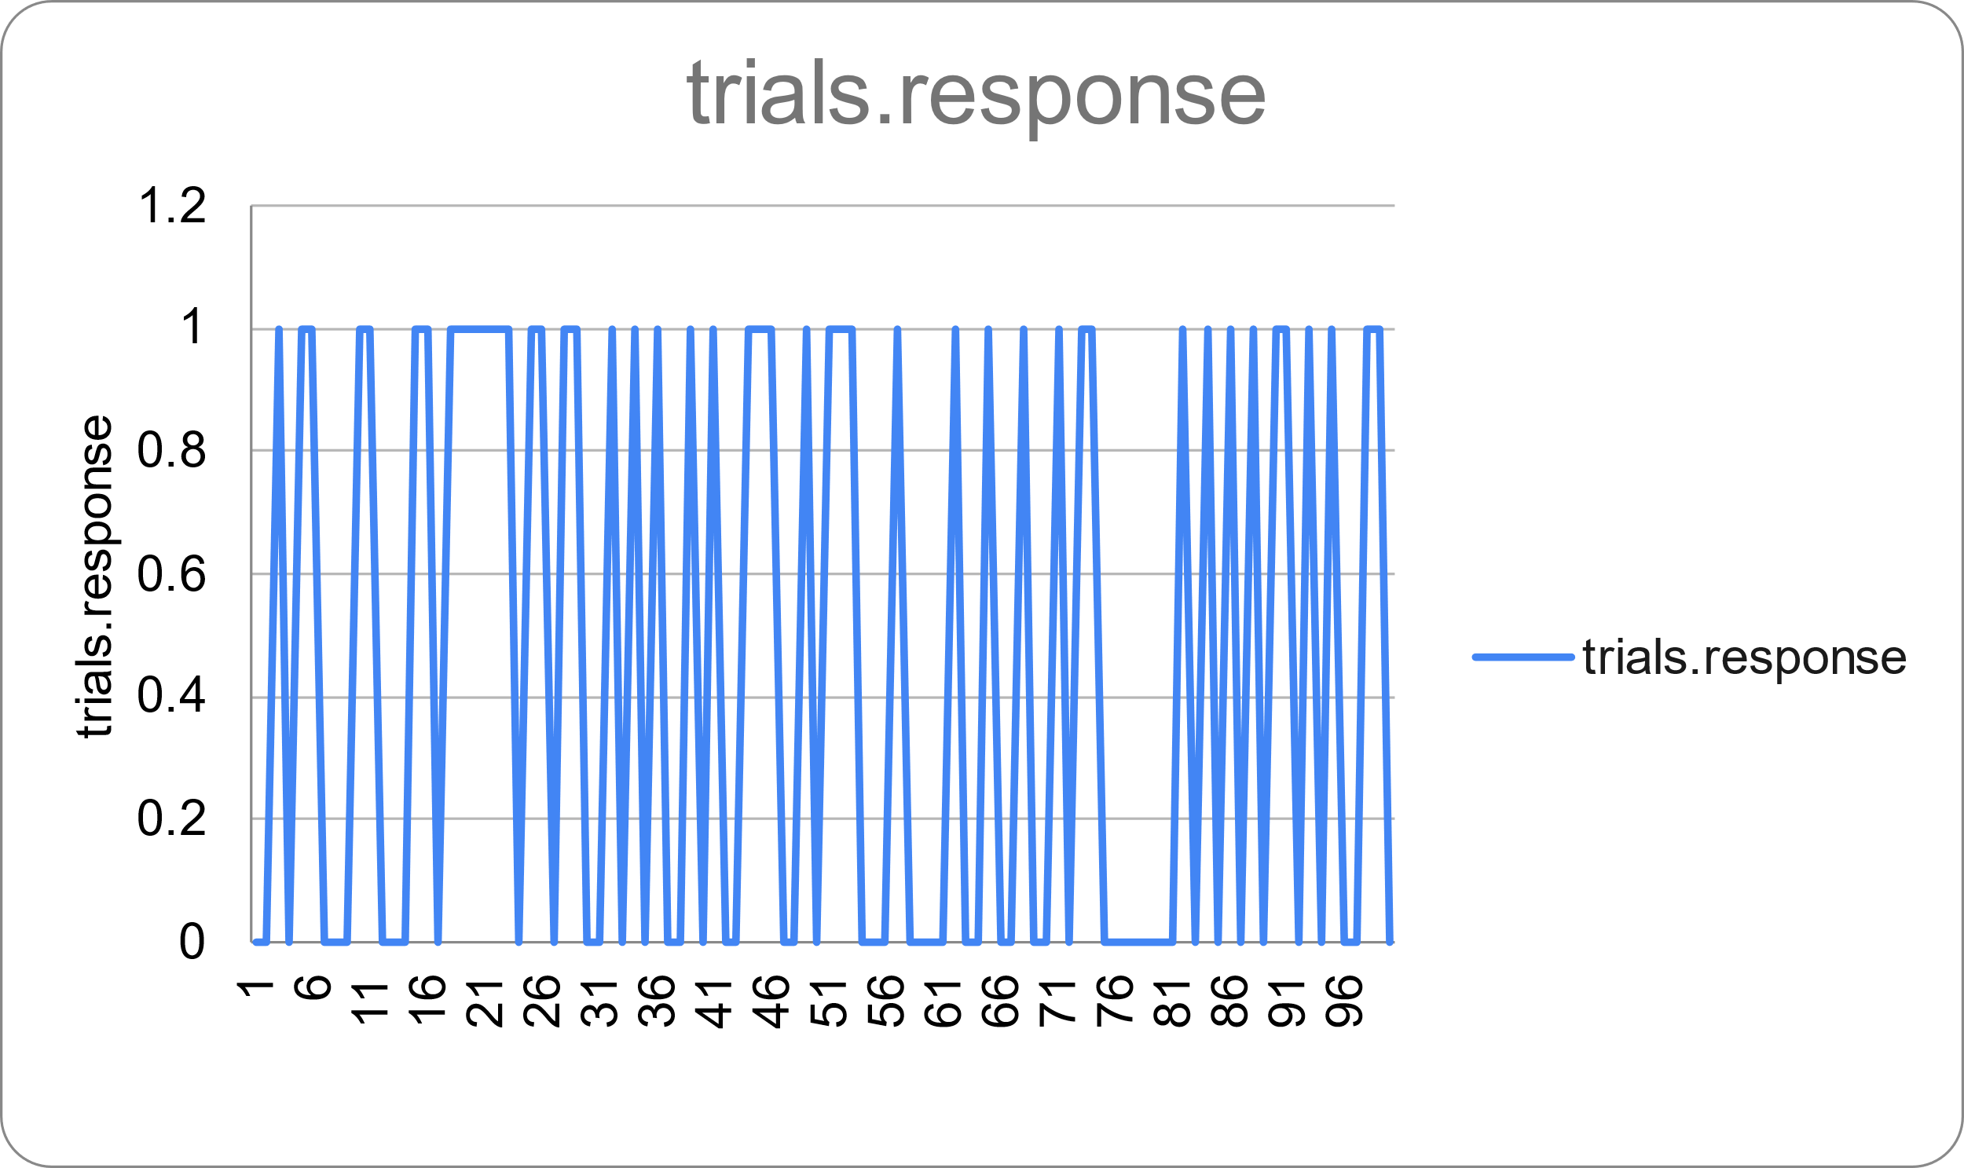

The accompanying chart displays the subject's replies' accuracy. Here, a response with a score of 1 indicates accuracy while one with a value of 0 indicates inaccuracy. We can observe from the aforementioned chart that there are numerous replies in the beginning that are both accurate and erroneous. We can examine how accurately the individual responded in between. We can observe the variety of reactions there.

Discussion

Having consciousness isn't onerous when the solutions are completely obvious, as they are in practically all psychophysical investigations. Problems arise, though, when the options are complicated. Once the staircase approach is implemented, participants are particularly attentive to how the raises are being sought. Regardless of whether he is entirely responsible or not, it won't take him long to realise the technique.